**Buyback Statuses:** The Buyback Statuses tab holds the CNH buyback status codes which are used to indicate what stage a buyback is at in the process.

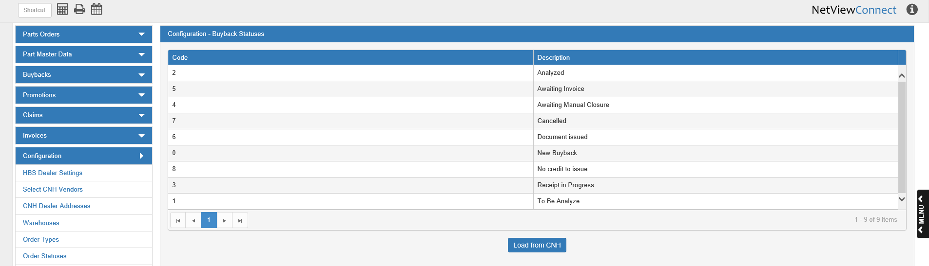

**Code:** This column shows the CNH buyback status code.

**Description:** This column holds the status description (Analyzed, New Buyback, Receipt in Progress, etc.).

**Load from CNH:** When you first open CNH Connect (CSPS), you will need to load the buyback status list from CNH, or you will not be able to process your buybacks correctly. After this button is first clicked, the list will automatically reload every 30 days, though you can also click the button at any time to load the most updated version of the list.